

**SOL:**

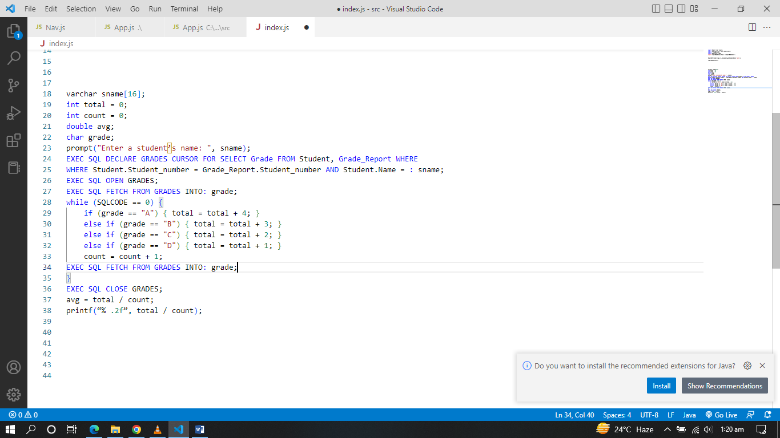

**Explanation:**

It is possible for a student to have several grades, so \texttt{CURSOR}CURSOR is used here. Cursor values are entered into grade variables and checked on \texttt{if}if statements. We are also getting the total grade of the student with /texttt{total}total while getting the number of grades with /texttt{count}count. In order to calculate the average, we divide /texttt{total}total by \texttt{count}count. With /texttt{.2f}.2f, you get a precise result of two numbers after a comma.

**Result:**

In order to get all the grades, use \textbf{CURSOR}CURSOR and while \textbf{FETCH}FETCHing each grade \textit{count}count the number of grades and sum them for the \textit{total grade}total grade. For the result, just divide the \textit{total grade}total grade to \textit{count}count.



**SOL:**

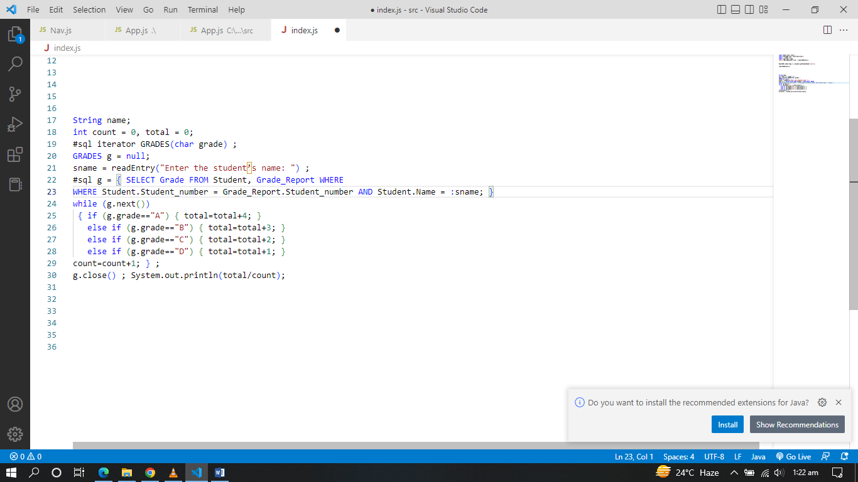

**Explanation:**

The same logic is used as in 7th exercise. There are some differences due to the programming language syntaxes.

**Result:**

In order to get all the grades, use \textbf{iterator}iterator and while \textbf{iterating}iterating the grades with .next() \textit{count}count the number of grades and sum them for the \textit{total grade}total grade. For the result, just divide the \textit{total grade}total grade to \textit{count}count.